MORE INFROMATION ON PRESENTATIONS

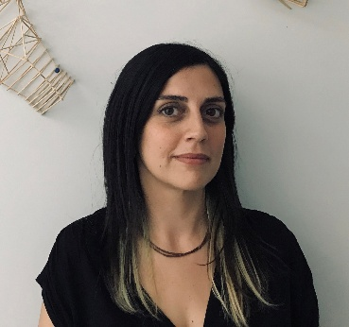
Elif Selena Ayhan Kocyigit (Baskent University/Ankara, Assistant Professor in the Department of Architecture) is an urban designer specialising in the conservation of cultural heritage. She completed her PhD in Conservation of Cultural Heritage at METU, Türkiye with a dissertation titled “A Tale of Ulus Square: A Critical Assessment of Continuity, Transformation, and Change in a Historic Public Open Space in Ankara”. Her research has been supported by Kaplan and ANAMED (2015-2016), Koç University-VEKAM (2017), and the Society of Architectural Historians/SAH (2022). She is an assistant professor at Baskent University and currently a postdoctoral researcher at TU Delft, Department of Urbanism. Her research interests include urban restitution, value assessment, and the conservation of historic sites, public open spaces, and multi-layered towns.
eayhan@baskent.edu.tr - linkedin.com/in/elifselena

“Why, for whom and how to conserve historic public open spaces?”
Historic public open spaces, which are complex entities formed by continuous interaction between the physical environment and human activity, are the reflection of and witness to history and the product of culture shaped by society. They are the stage for cultural practices and can thus be defined as sites of collective memory. Therefore, the issue of historic public open space conservation is crucial not only for sustaining the continuity of physical aspects but also for remembering the common values that are shared by members of society, which emerge as the outcome of collective thinking, various actors, and consecutive events. Despite their unique characteristics and importance to society, historic public open spaces are among the most vulnerable elements of urban environments and are under threat of rapid transformation and demolition. Even though there are conservation policies in response to this threat, most of these policies focus on the continuity of physical aspects, particularly emphasising historic buildings. This has resulted in the loss of authenticity, integrity, heritage values, and cultural significance of these areas.

At this point, the lecture shifts the focus from building-oriented practices to society-driven processes, and introduces a methodological approach for revealing the significance of historic public open spaces. It first presents urban restitution as a systematic framework for understanding values, followed by a discussion on value assessment for defining cultural significance.

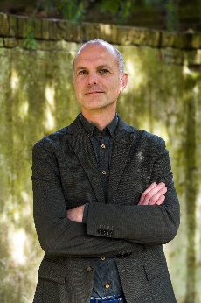
Maurice Harteveld (TU Delft, Assistant Professor in the Section of Urban Design of the Department of Urbanism) affiliated with the Chair of Urban Design at TU Delft, has a long-standing focus on public space. Over time, this focus has evolved towards an intercultural understanding of ‘human space’, exploring how architecture and urban design engage with people across diverse places and societies. His epistemological research contributes to the repositioning of public space, the advancement of transdisciplinary thinking, and the development of urban history and design theory. His theoretical concepts of ‘interior public space’ and ‘interior urbanism’ have brought together diverse design disciplines while particularly advancing the boundaries of urban design through micronarratives hidden histories. Building on this, his evolving work on e.g. ‘domesticated public space’ similarly intersects with cultural anthropology, urban sociology, and environmental psychology. This approach has guided him to develop transdisciplinary and context-sensitive methods.
linkedin.com/in/mgadharteveld - instagram.com/mgadharteveld - m.g.a.d.harteveld@tudelft.nl

“The Value of Memories in Public Spaces”
Urban designers and landscape architects often approach public space from its physical form, working within the boundaries of publicly owned land and the assumption that these spaces are meant for public use. Design is expected to shape behaviour and activities, and through this anticipated use it implicitly produces meaning. Even when heritage values are considered, the focus typically remains on spatial objects, meaning that the material turn in urban history largely remains unchanged. Those elements of the past that fit the dominant narrative are deemed important enough to be preserved for future generations.

By shifting the focus from objects to the lived experience, the lecture explores in what ways memories of the city are formed from the streets. In today’s hyper-diverse urban societies, recognising these layered and plural memories is essential for understanding the meaning of the past and, thus for designing more inclusive heritage public spaces in the future.

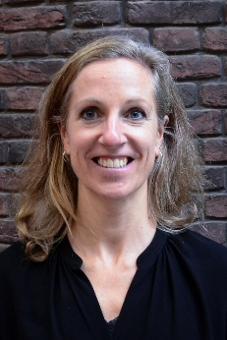
Lidwine Spoormans (TU Delft, Assistant Professor in Heritage & Architecture) was trained at Delft Technical University as an architect and architectural engineer and studied at Arkitekthøgskolen in Oslo. After working in architecture offices on designing new construction and renovation of mainly large-scale housing projects, she founded Studio LS, a practice for design and research in architectural transformation. Since 2010, she has worked for the chair of Heritage & Design at Delft Technical University. She organised a series of graduation studios on the topic of housing heritage and neighbourhood renovation. She specialised in housing renovation, building systems, intervention methods, and young heritage. Researches she conducted include strategies for energy-efficient housing transformations, analysis of adaptations of traditional Japanese townhouses, overview of end walls of Dutch housing typologies and a biography of the post-war housing area Ommoord. In 2017, she initiated the digital platform ‘Love 80’s architecture’ (www.love80sarchitecture.nl). Her PhD thesis titled “Everyday Heritage - Identifying attributes of 1965-1985 residential neighbourhoods by involved stakeholders” reveals new knowledge on young heritage and stakeholder involvement. Her current research aims to bridge the gap between listed heritage and everyday architecture.
L.G.K.Spoormans@tudelft.nl

“The value of historic public space”

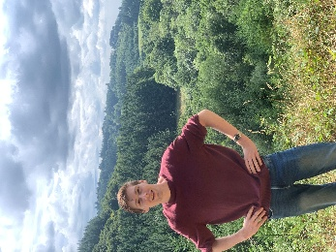
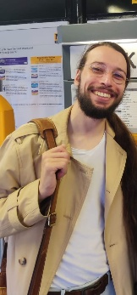
Mosilàh Shafiei Sabet (TU Delft) is a 4th year architecture student at TU Delft. Followed the TU Delft minor Heritage & Design in Q1&Q2 2025/2026.
https://www.linkedin.com/in/mosilah-shafiei-sabet-5a1a883b6/
Twan van de Poel (TU Delft) is a 3rd year architecture student at TU Delft. Followed the TU Delft minor Heritage & Design in Q1&Q2 2025/2026.
www.linkedin.com/in/twan-van-de-poel-2b4653244
Gerdy Verschuure-Stuip (LDE Global Heritage and Development, Program coordinator), assistant professor of landscape architecture is involved in international and national research projects regarding heritage value assessment, heritage & participation, heritage & water, and innovations in agriculture. She is using narrative methods like landscape biography as a bottom-up approach to analyse and design the identity of place. She is also a cluster leader (research leader) for the inter-university cooperation LDE Centre for Global Heritage & Development, and co-organising and steering interdisciplinary cooperation in cross-over projects (students) between academic research, local stakeholders and education in community engagement projects on heritage transformation. She is a co-editor of several books, articles, and exhibitions of heritage issues like Zuiderwaterlinie, Planted Avenues, Atlantikwall, New Dutch Waterline, Country Estates, etc.
G.A.Verschuure-Stuip@tudelft.nl

“Redesign of the public space around churches”
The presentation will address a landscape design project next to the Nieuwe Kerk for the TU Delft minor Heritage & Design. Artworks, sightlines, and flora fuse into an intricate, inviting, and above all educational experience for tourists and inhabitants of Delft alike. The main objective for a landscape design is to capture the essence of the location, how do all its parts contribute?

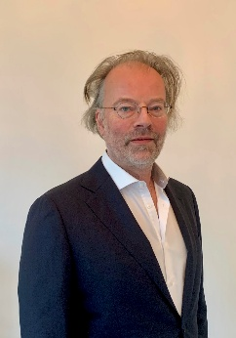
Jaap Evert Abrahamse (National Heritage Department and Vrije Universiteit Amsterdam, Special Professor city, landscape and heritage) studied Art, Architectural History and Archaeology at the University of Groningen and obtained his PhD cum laude at the University of Amsterdam on a study on the spatial development of Amsterdam in the seventeenth century. Since 2007 he has been a senior researcher at the RCE. Before that, he was a researcher and advisor at the municipality of Amsterdam. He is a member of the editorial board of the Journal of Historical Geography, the editors of the series Historical Atlases and the board of the Research School of Art History.
j.e.abrahamse@vu.nl

“The historic public space for the future of cities”

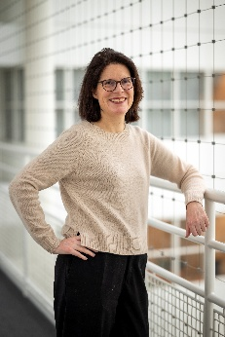
Almut Röwekamp (Den Haag Municipality, Senior Landscape Architect) studied at Wageningen University and began her career in several design offices as well as the Municipality of Rotterdam. For twenty years, she has worked for the Municipality of Den Hague, specializing in public-space design in the inner city- including the historic surroundings of the Dutch Parliament.

“How to Re-design a Historic Public Space. Examples form The Hague”
Through examples from recent projects, the presentation shows the usage of historical knowledge as a design tool to create urban environments that integrate history and future- proof spatial quality.

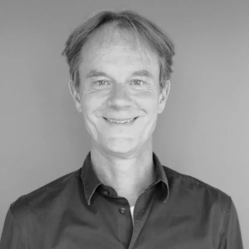
Harm Veenenbos (Veenenbos en Bosch Landscape Architecture, Project leader) is an experienced landscape architect. Over the years, he tackled a wide variety of assignments, his professional knowledge is broad. He worked in the city and the countryside, on visions, design and implementation and to both site layout and regional design. In addition to the projects, he has always worked as a teacher and advisor. https://veenenbosenbosch.nl/

“Blauwe Golven revisited”
Blauwe Golven was designed by Peter Struycken in the late 1970s as a bold artistic response to offset the harsh infrastructure of the ramp and overpass to the new Nelson Mandela Bridge. It is the largest public landart artwork in Europe, characteristic of its era. The artwork originally allowed for parking, reflecting the atmosphere of the historic harbor, originally located on this site. In recent years, significant adjustments were made to the infrastructure, but the surrounding area and the artwork itself were neglected.

The redesign involves targeted interventions of a varied character: artwork, borders, and location within the urban fabric. The plan restores the artwork Blauwe Golven to its former glory, emphasizing craftsmanship and attention to detail. The surrounding edges have shed superfluous pavement creating more space for greenery which in turn helps to counterbalance the amount of pavement in the artwork and remaining infrastructure. A newly designed lighting plan introduces a distinctive nocturnal atmosphere, enhancing the artwork after dark. This way, the iconic landmark of the city is restored and even enhanced.

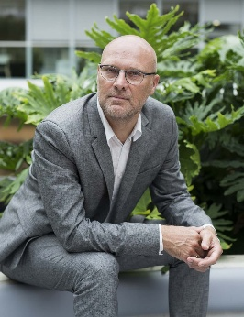
Ben Kuipers (Landscape Architect) educated at Wageningen University and with a professional experience of 40 years designing public space. Using genius loci, which includes historic artefacts and narratives, as an important source of inspiration to create specific meaningful pubic space.
www.benkuipers.nl

“Experience Religious history in public space of Brielle”
The city of Brielle played an important role in Dutch national history during the struggle for freedom against the Spanish rulers. Religion was a main issue in the Eighty Year's War against the King of Spain. Making it possible to discover traces of this religious heritage in public space was the ambition of the municipal government. Many obstacles had to be overcome. Judge for yourself if they succeeded after a presentation of several projects.

