Heritage and Identity Dossier
Values of Craft Expert Meeting 30/3-31/3
Uli Botzojorns

Putting Value at the Centre: Studying Craft Across Disciplines

Trevor Marchand from SOAS University eloquently summarized the conversations, questions, and revelations that occurred over the two day Values of Craft Expert Meeting. To paraphrase, Trevor said that the study of craft can change our perception of what knowledge is. From this we can redefine scholarship, curriculum and reform education. Craft and craft culture can have radical impacts on our understanding of societal structure, identity, valorization, and general wellbeing. Despite their differences throughout the meeting, the diverse group of scholars and crafters were able to come together at this statement after two days of workshops and presentations. Each individual’s questions and goals for the future of craft and craft research were varied and sometimes even conflicting, and yet there was a common recognition of craft and its impact on future society.

The meeting was organized by Maikel Kuijpers, from the Archaeology Faculty of Leiden University and coordinator of the Leiden-Delft-Erasmus Centre for Global Heritage and Development, who hosted the event. The goal of the seminar was to explore cross-disciplinary approaches to craft. As the researchers had diverse perspectives on the field, key questions were how the various approaches to craft are interrelated, and whether they converge in a shared set of research aims for the future. Attendees included scholars working in Archaeological Heritage and Sciences, Critical Heritage, Economics, Arts and Culture studies, Anthropology, Material Culture Studies, Values Technology and Innovation, and Policy. Attendees listened to presentations and participated in workgroups to discuss questions and definitions, relevance, and case studies.

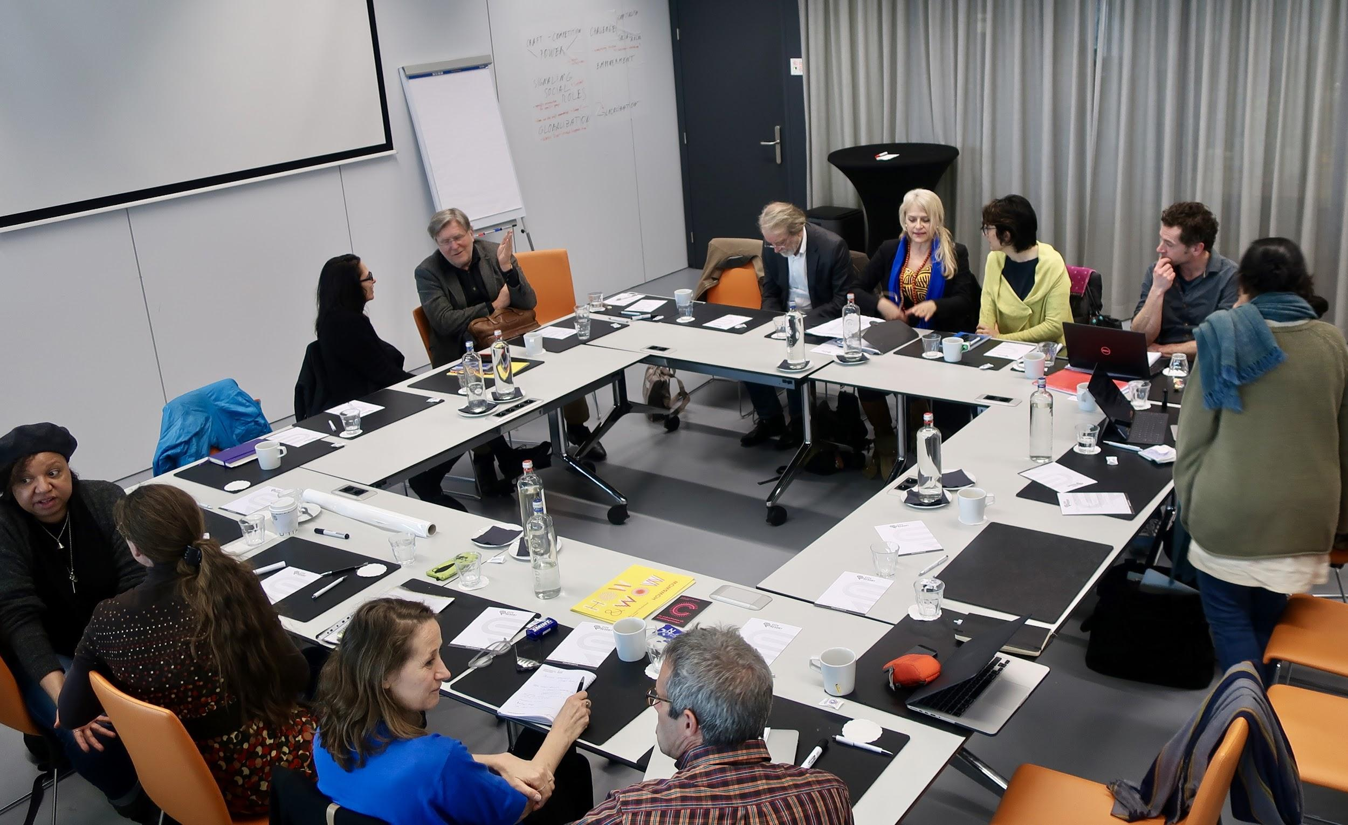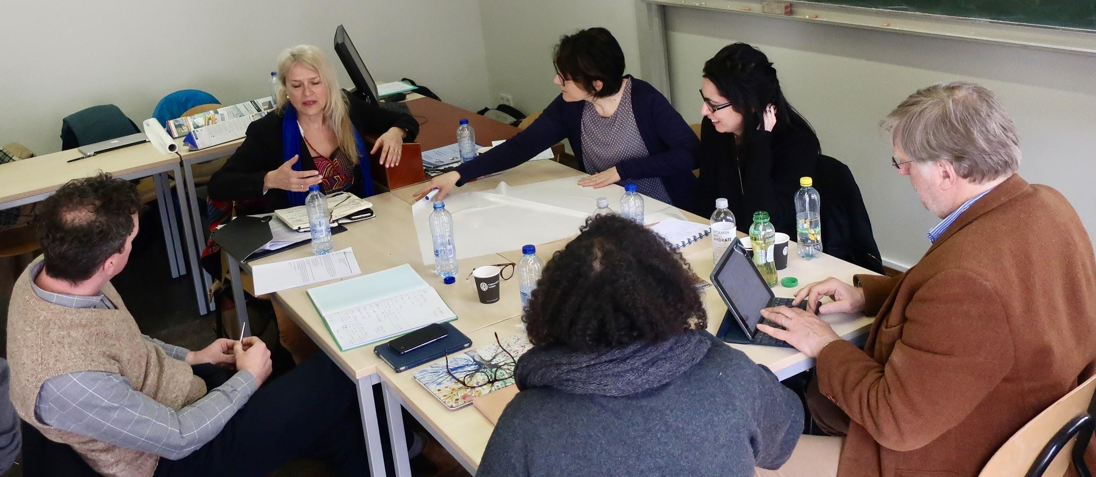
The meeting was highly collaborative, and was organized around workgroup discussion.

There were four work groups, each with a chair who is an expert in the topic and worked to inspire discussion: Skill, cognition, and learning chaired by Trevor Marchand, professor of Social Anthropology at SOAS University; Values, economies, and craft as heritage chaired by Arjo Klamer, professor of cultural economics as Erasmus University Rotterdam; Politics, identities, and craft communities chaired by Catalin Popa, post-doctoral researcher at Leiden University Archaeology Faculty, who specializes in past and present identity and ethnicity; Materials, design, and sustainability chaired by Udo Pesch, professor at the Delft University of Technology where his research includes responsible innovation, science and technology studies, technology dynamics, environmental politics, policy, and philosophy.
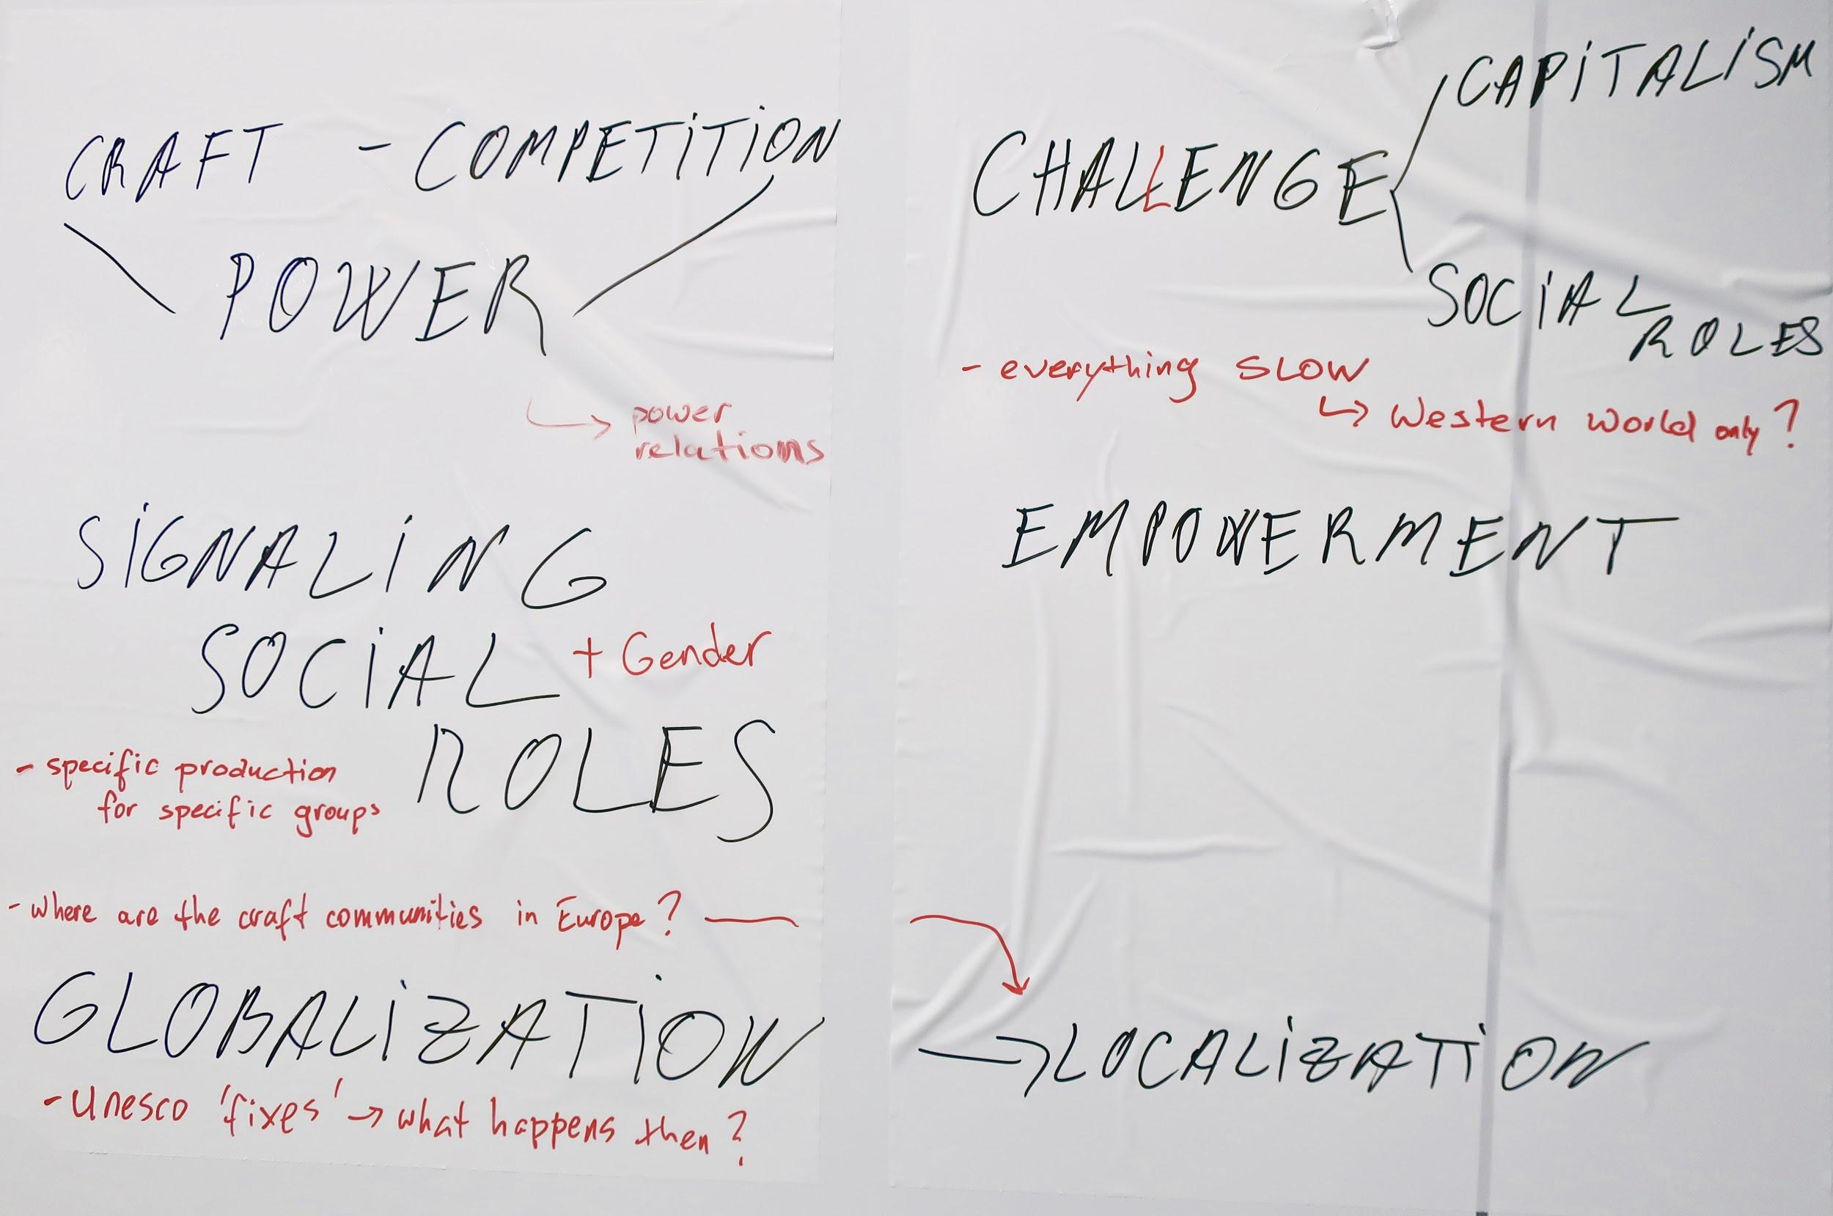
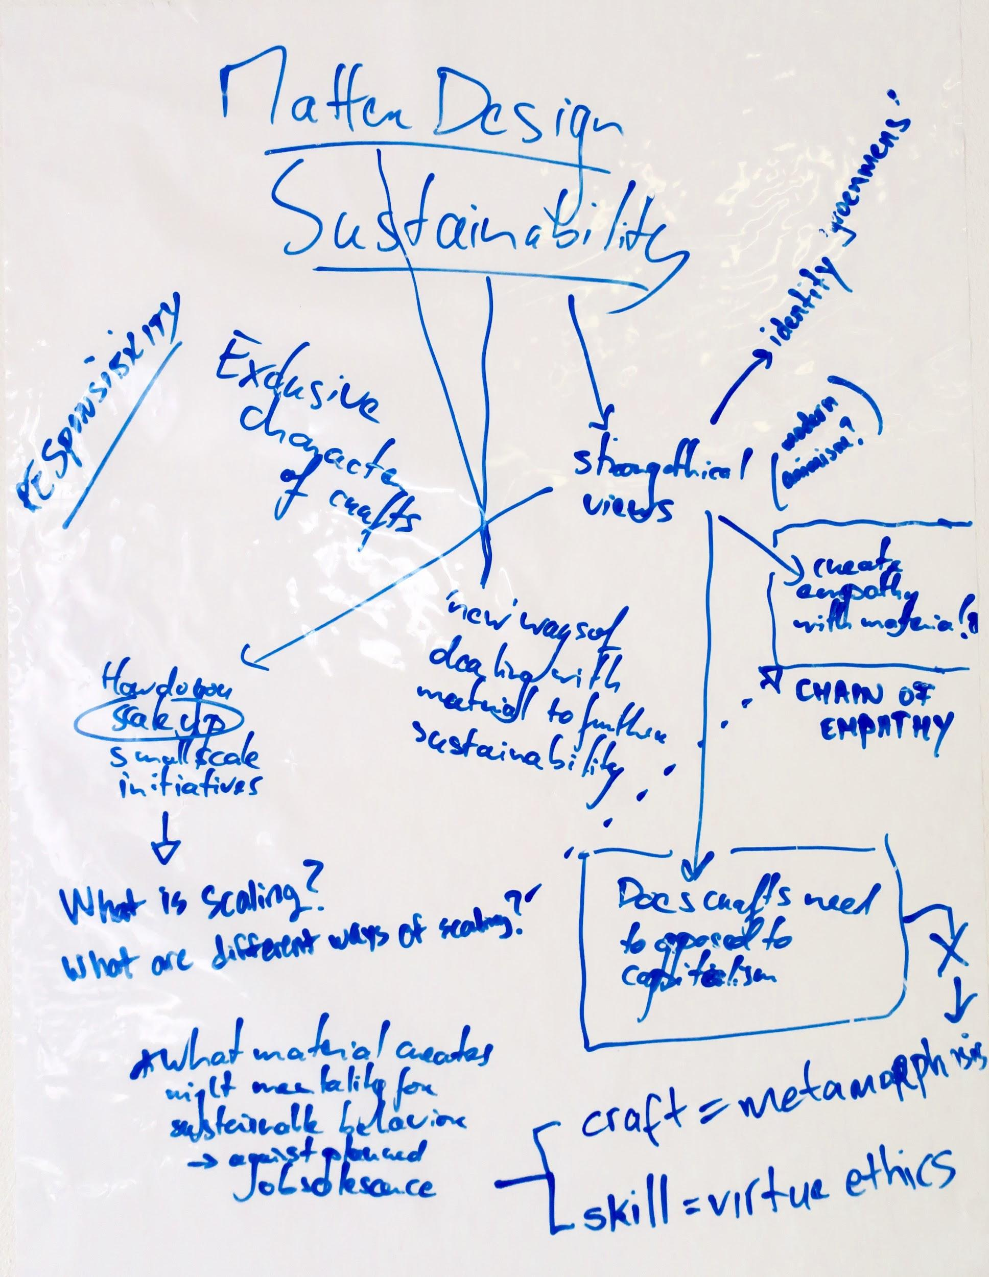
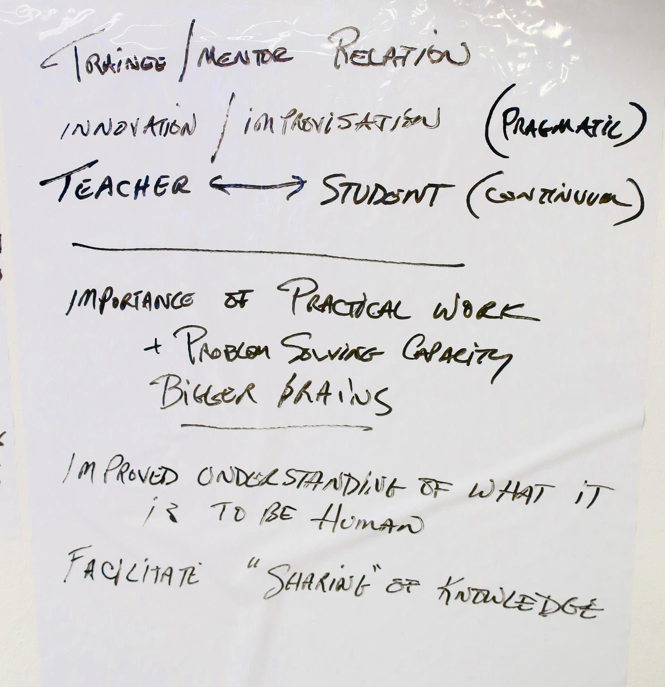
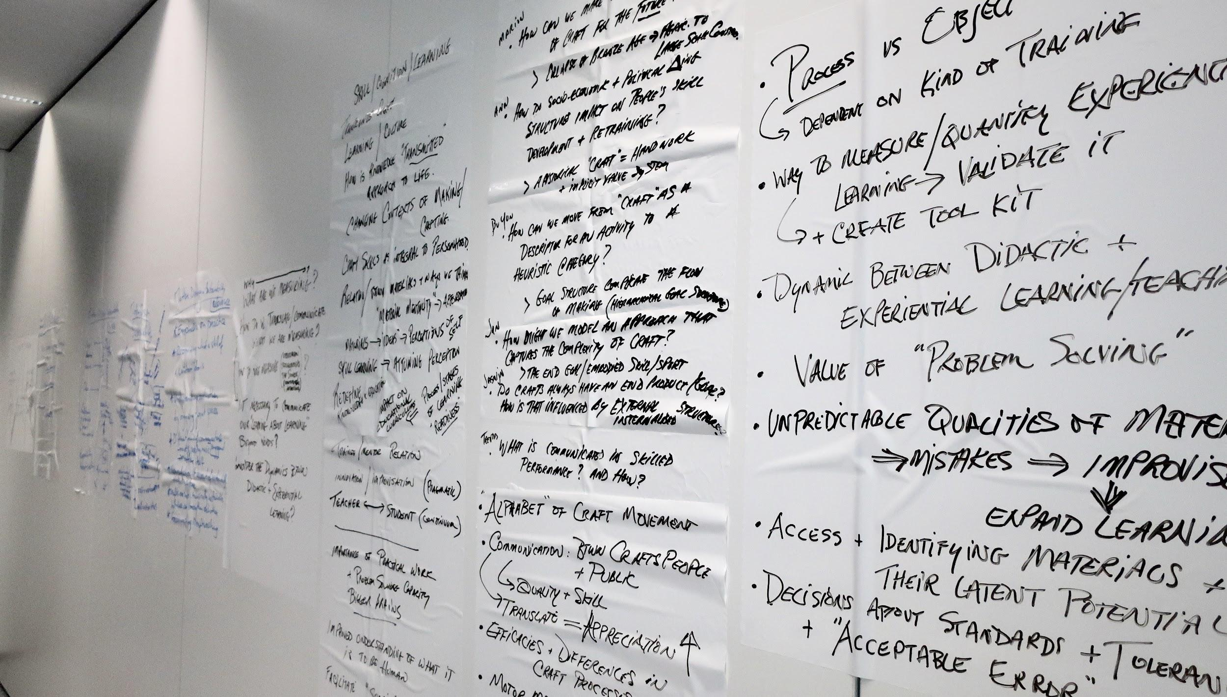
A visual representation of the brainstorming that came out of the workgroup sessions.

The common themes of presentations and workgroups can only be roughly summarized, but three broad threads emerged: communication, measurement, and inclusion.

Communication addresses scholars’ role in bridging the gaps between researchers, crafters, and the public. As an example, Annapurna Mamidipudi stressed the importance of involving craftspeople throughout research. Annapurna works with Indian weavers and addressed the problematic nature of defining craft knowledge as tacit knowledge rather than just knowledge. She argued that by making this distinction, it forces researchers to “translate” tacit knowledge into scientific knowledge, which then becomes nonsensical to craftspeople. With that in mind, perhaps our goal as scholars should be to find a common language rather than translation.

One path to a common language comes through measurement. Attendees were divided on the what, how, and why of quantifying craft, but there was no doubt that some aspect of quantification was relevant for all those attending, whether it was to communicate meanings of craft knowledge, to identify qualities in craft made objects, or to impact policy. As an example, by measuring skill and quality, those outside of traditional ‘craft-minded’ disciplines [e.g. critical heritage, design, or archaeology] could more readily legitimize alternative knowledge systems in their own education and research [e.g. economics or engineering].

Measurement and communication were especially relevant when the workgroups discussed possible case studies. The skill, cognition, and learning workgroup focused on the process of studying the skills and knowledge of craftspeople. Jan Apels’ presentation discussed his research into measuring technological complexity; Jan uses lithic experts to map hand movements in different lithic technologies, which then allows him to create an “alphabet of gestures” and compare percussion complexity and hidden states of movement to study the cognitive patterns in skilled work. The attendees saw ramifications of this research in educational discourse. There was general agreement around the importance of educational reform and working with young people to encourage the valorization of craft through experiential learning.

The economists in the room addressed the consumer perspective and the meaning of craft to the general public. Arjo Klamer from the Erasmus University Rotterdam is developing a “quality impact monitor” that would contribute to the measurement and communication of a value based economy. Udo Pesch from the Delft University of Technology works with engineering students on responsible innovation and was intrigued by Richard Sennett’s concept of “metamorphosis” in craftwork.

This leads directly to the next theme - inclusion. The attendees generally acknowledged the necessity of inclusivity in our research. Inclusivity pertains not just to the inclusion of craftspeople, the public, and academics, but also to the barriers of expense and exclusivity of craft objects (primarily in the West), as well as the presence of “craftivism” and exclusive identities as tied to craft. Heidi Jie, from the International Institute for Asian Studies at Leiden University, is also a quilter. As a craftsperson, she challenged us to consider the ramifications of our work, and to find what Annapurna termed “symmetry” in our relationships and research with craftspeople. Academic researchers run the risk of attributing values to craft within the context of academia that are irrelevant and superfluous to craftspeople. Additionally, crafts can play a unique role in connecting people. An example was given of craft’s role in the visibility of humanitarian crises. By engaging with materials and objects, communities outside of those affected are more likely to empathize and connect to those in crisis; craft incites an emotional reaction.

Towards the conclusion of the meeting, the politics, identities, and craft communities workgroup made an important point about contrasting views of craftwork in Europe and the Global South. In Europe, often the most powerful stories about craft come from history, and the problem craft faces in Europe is that scientific knowledge “won” over craft knowledge. Because of this, people are prone to be nostalgic and romanticize craft, which is problematic for communities actively engaged in craftwork as well as for our understanding of craft’s role in discussions of heritage. This way of thinking is often transmitted onto the Global South, where valorization of different types of knowledge is sometimes structured quite differently.

Craftwork produces both tangible and intangible heritage, and from the beginning of the meeting attendees were divided on definitions of craft as it fits within heritage designations. There was agreement that craft as heritage is a challenging space, but how and when to define these terms together found little agreement, especially across disciplines. As is often the case in diverse research groups, people found that their definitions were informed by the questions they were asking; an economist was interested in the sense-making and value systems that surround communities of craft, while an archaeologist asked about how the material mentalities are formed in craftwork. On the surface, the diversity of research seemed potentially incompatible, and yet the group did find a common ground when BuYun Chen from Swarthmore College and Max Planck Institute for the History of Science reminded us of efforts to define craft as a heuristic category. By doing so, the group generally agreed that we could move beyond insistence on categorical definitions of craftspeople and craft objects and instead turn to bigger questions of knowledge, skill, and identity.

So where do we go from here? The goal of the meeting was to find common research questions, and by the end of two days there was quite the list. A sample of the questions that arose from workgroups’ discussion included:
- How do materials influence our thinking?
- What are the values of crafts, what do we lose when we lose crafts?
- How does craft create an identity and what kinds of identities are developed?
- How can you describe the dynamics of craftwork without the full experience, or how can you capture without doing?
- How do we valorize craft? In valorization are you focused on making (craftspeople) or giving meaning (consumers/community)? Can we quantify value?
- How could research into cognition/learning inform the general curriculum in the school room?
- How can you measure the relevance of craft in an economic context?
- Can craft bridge cultural differences or animosity across groups and establish a basis of dialogue?
- How can we involve craftspeople?
- What does it mean for people to practice a skill? What is important?
- How does craft interact with a capitalist economy?

Are you interested in these themes and research questions? Do you think craft research might apply in your discipline? Do you already see the relevance of craft in your work? With any questions please contact Maikel Kuijpers at m.h.g.kuijpers@arch.leidenuniv.nl

