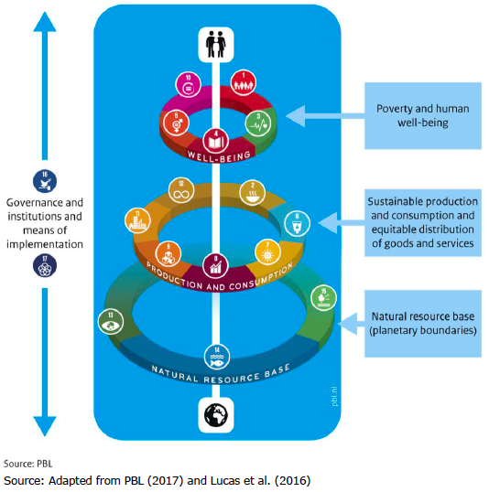
SESSIONS
1. Time: Evolution and Dynamics
Culture & Sustainability is a field in fast development in the last decade, seeing governments, heritage organizations and academics exploring the role that culture and heritage can have in achieving sustainable development. Past research aimed to the integration of culture and heritage in the United Nations’ international agendas for sustainable development, which led in 2016 to the mention of heritage in SDG number 11.4 “Strengthen efforts to protect and safeguard the world’s cultural and natural heritage”, to be measured through a financial indicator. Although, existing research supports a broader contribution of heritage to sustainable development, therefore, many management and policy frameworks and guidelines have been developed to underline this role, such as the New Urban Agenda, Strategy 21 and HUL, among others. What is being done to develop and implement these frameworks, dealing with reality’s dynamics and cities’ constant change? Which actors are involved in these dynamics and how does it all affect heritage professionals’ ambitions and goals?

2. Roles: Tasks and Influences of Stakeholders
The Heritage & Sustainable Development field is characterized by an intrinsic multiplicity. Sustainability has different dimensions – environmental, social, economic and cultural – which are addressed by several heritage disciplines and professionals, each with their own specific perspective and language. On the other hand, heritage can include a variety of attributes and values, which are determined by different stakeholders, with their own interests and ways to interact with heritage assets. Heritage management needs to deal with the complexity of actors involved in the process, plan and regulate their interventions, on a local, national, regional and international level. In order to do so, it is crucial to understand: who are heritage stakeholders? What are their roles and responsibilities in heritage management? How is their participation regulated?
3. Disciplines: Capacities and Limitations
Over time, the meaning of cultural heritage has broadened from single monuments and objects of art to cultural landscapes and historic cities, by expanding the concept of heritage beyond its materiality and integrating intangible values. As a result, different disciplines and expertise, ranging from archaeology to social sciences, have entered the domain of heritage management and conservation. The resulting multidisciplinary can enhance heritage potential impact on sustainable development, by drawing knowledge from a variety of professionals with diversified expertise, addressing more dimensions of sustainability and facilitating transdisciplinary collaborations. On the other hand, multiple stakeholders from different disciplines have different priorities, viewpoints and approaches. The theme therefore embraces all papers discussing the potentials and limitations brought by different heritage disciplines in relation to the implementation of the Sustainable Development Goals.
4. Place: Local Reality vs global Ambitions
International heritage organizations set ambitions to foster innovation in the heritage field through guidelines, declarations and conventions, providing soft laws that individual countries can adopt and to which they can comply with. They are drafted by professionals and academics coming from different disciplines, expertise and geographical areas, during international meetings aimed to find common ground and direction. Although, implementation on a national and local level can present administrative, political and regulatory challenges, which vary from regions, countries, provinces, cities, until occasionally even neighbourhoods. On the other hand, without local consensus and efforts global ambitions can not be met. How are different local realities implementing global policy frameworks and guidelines? How can local realities learn from each other on an international scale? What are the challenges and how can the gap between global ambitions and local realities be addressed?
5. Heritage and Well-being
Overtime the concept of sustainability has evolved in a more holistic sense, to integrate social, economical, environmental and cultural dimensions. In the context of the SDGs, the cluster well-being (SDGs 1, 3, 4, 5 and 10) interconnects people-centred goals that reflect the social foundation of sustainability. These goals have been stressed out as an essential part of the sustainable development agenda, in order to end poverty and ensure equitable access to health and education. The topic Heritage and Well-being embraces reflections on the contribution of heritage to the empowerment of communities, inclusive societies and quality of life.

6. Heritage, Production and Consumption
The cluster Production and consumption (SDGs 2, 6, 7, 8, 9, 11 and 12) reflects on the intersections between people’s needs and the biophysical systems. It also reflects on the production and consumption of goods and services – such as food, energy or water – and on the consequent environmental pressures and impacts. This theme embraces papers discussing the role of natural and cultural heritage for sustainable consumption and production patterns, resilient cities and infrastructures, circular economy and affordable energy.
7. Heritage and the Natural Resource Bases
The world is experiencing unprecedented changes with critical impacts over irreplaceable resources such as biophysical systems. Considered as the support of sustainable development, the cluster Natural Resource Bases (SDGs 13, 14, and 15) aggregates the natural environment goals addressing the governance of natural resources and public goods such as land, oceans, biodiversity and the management of climate change. Contrary to heritage resources, these natural systems are not dependent on human activities, but human activities have a serious influence on them. This theme addresses papers entwining the concerns integrating heritage and the governance of these three natural environment resources on the sustainable development race.
8. Heritage, Governance Institutions and Means of Implementation
The extension of the heritage scope has been pushing heritage management field towards more inclusive approaches. A process that grows to integrate distinct aspects of heritage nature and bringing together governments, the private sector, civil society, international organizations and other deemed actors. An integrated approach that recalls on the urgency for transparency of governance institutions and the promotion of human rights on the way to more sustainable development models. To implement it is crucial to strengthen partnerships based on the cooperation at financial, technological, trading and capacity-building scales. The present cluster (SDGs 16 and 17) relates to all papers reflecting the relations between heritage and the adopted governance models, approaches and instruments to implement the Agenda 2030 strategy.

9. Heritage, SDGs and the next Generation
The integration of heritage in the sustainable development discourse takes time and faces many challenges. Professionals from different disciplines have been working in the past three decades towards understanding and spreading awareness over this topic, and with the SDGs the first international and interdisciplinary recognition has been achieved. In 2030 a new United Nations’ sustainability agenda will be adopted and the new generation of heritage professionals will bring forward the heritage & sustainability cause. Intergenerational collaborations are essential to ensure continuity. What are heritage organizations doing to ensure this continuity? What are new generations’ visions, utopias, scenarios and how do they cope with the challenges they face? This theme is a platform to young generations to address how they think out of the box, how they think the unthinkable.

