Re-Scape Colloquium: Campus heritage
October 11, PJ Veth Building, Nonnensteeg 3, Room number
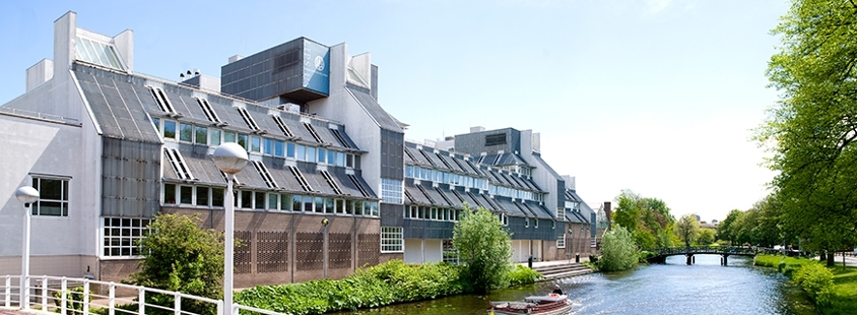

“Discover the World at Leiden University.” This is how Leiden University promotes itself. The city of Leiden uses the slogan: “Leiden: Key to Discovery.” The strong similarity between the two is of course no coincidence. Since the founding of the University in 1575, the city and the university have been closely interrelated. Exploration, discovery, studying languages, cultures, arts, the history and material remains of societies worldwide stands at the heart of the University ánd the city. Leiden University hosted a number a world-famous professors, like Cleveringa, Clusius, Einstein, Huizinga, Lipsius and Thorbecke. Their legacy can sometimes still be traced in the physical environment. Buildings and streets are named after them. Some of the Leiden professor’s collections shaped Leiden museums (Boerhaave, Sieboldhuis, Ethnology, Antiquities) and of course the Hortus Botanicus. With its iconic buildings as the Academy building and the Sterrewacht, the university can be found everywhere in the city of Leiden.
The Centre for Global Heritage and Development regards the region of South Holland as a ‘living lab’. It wants to put campus and academic heritage in Leiden, Delft and Rotterdam (LDE) on the agenda. There is also a current interest to it. In the inner city of Leiden and Delft Campus, some of the Faculty buildings are in need of replacement. Several activities are organized by the Centre to look for answers as how we can incorporate the history, atmosphere and legacies of the area, revive the ‘sense of place’, and in this way contributing to the long-standing academic tradition in new and recognizable ways.

Re-Scape Colloquia
Research on spatial heritage is scattered over many academic disciplines, such as architecture, architectural history, archaeology, urban history, landscape studies and heritage studies. The Centre for Global Heritage and Development (Leiden University, Delft Technical University and Erasmus University Rotterdam) and the VU Amsterdam research institute CLUE+ organize the Re-Scape colloquia for young researchers and graduate students, to be inspired by experienced academics and professionals, learn from each other by sharing knowledge and progress on their own research and work. The colloquia are also open to anyone who is interested in heritage in its spatial setting.

Programme (subject to change):
(in the morning a PhD and MA thesis colloquia will be held by Linde Egberts and Gert-Jan Burgers respectively (10:30-12:00/ PJ Veth Building)
13.00 Welcome by dr. Linde Egberts
13.10 Future Challenges for Dutch University Campuses and their Heritage
To be announced
13.30 Heritage and Transformation of the Humanities Campus of Leiden University
Chris Suijker, Project manager Real Estate Centre of Expertise, Leiden University
13.40 Guided tour through the Humanities Campus including observation assignment
Elisa Meijer, Housing advisor of the Faculty of Humanities, Leiden University
14.40 Statements by panel experts,
Experts to be announced
15.30 Discussion of observations
16.00 Closure by dr. Linde Egberts
16.10-17.00 drinks Café Barrera, Rapenburg

